# Dataset Description

## Dataset Overview

**Organization Name:** clalit innovation

**Number of Records:** 1000

**Data Domain:** family

## Cohort Characterization

**Number of Distinct Patients:** 961

**Medical Indications Covered:** none

## Text Content Details

**Minimum Text Length (total terms):** 6

**Average Text Length (total terms):** 257.04

**Maximum Text Length (total terms):** 3386

## Dates

**Date Range of Records:** 2017-01-02 to 2023-06-30

## Data Source

**Original Data Source:** clicks

## Language Analysis

**Hebrew Count:** 941

**English Count:** 0

**Mixed Count:** 59

**Hebrew Ratio:** 94.10%

**English Ratio:** 0.00%

**Mixed Ratio:** 5.90%

*Note: Mixed texts are classified as such when more than 10% of the text words belong to a secondary language.*

## Distribution of Text Lengths

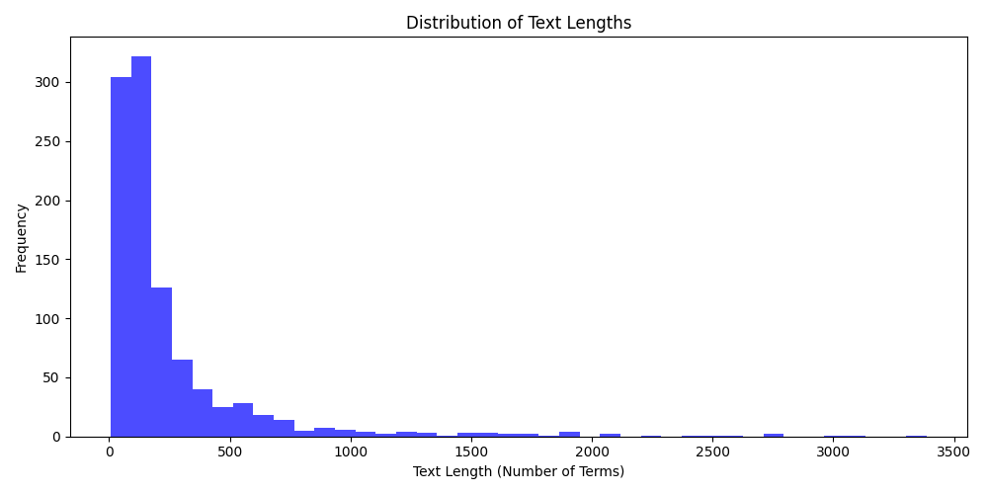

## Distribution of Record Dates

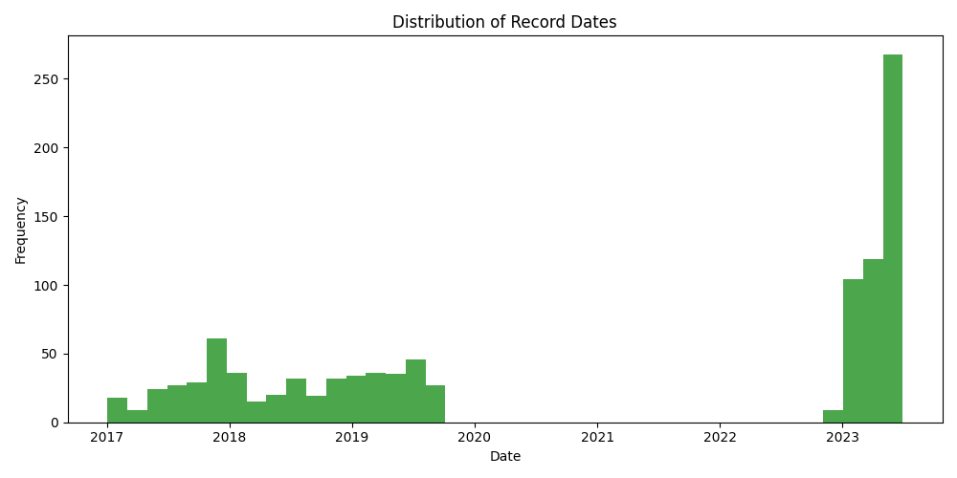

## Language Distribution

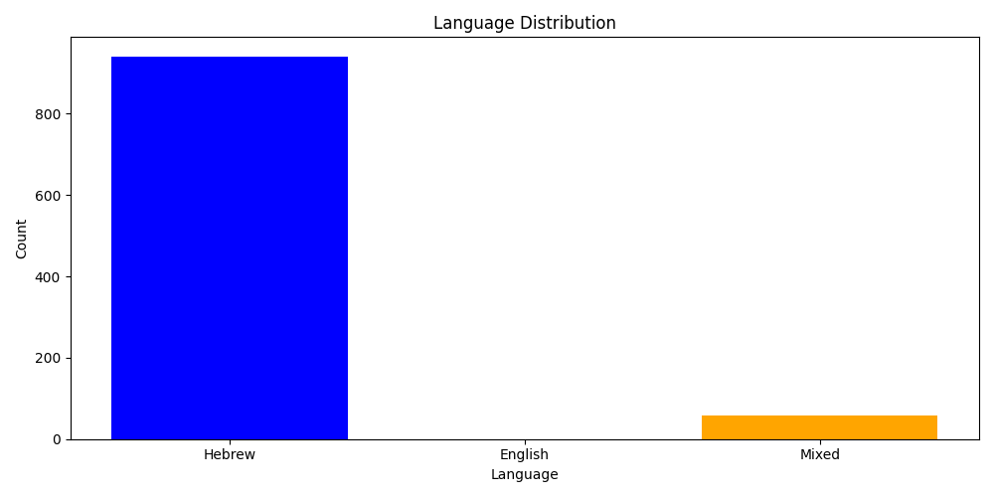

*Note: Mixed texts are classified as such when more than 10% of the text words belong to a secondary language.*